Robert Boyd
Program 8 Analysis

The following table and chart illustrate the adherence of my hash table implementation to expected results. My results closely mirrored the expected unsuccessful: λ, successful: 1 + 0.5λ for the various values of the load factor. The average percent difference between test and theoretical results was .04% This small variation is likely duo to repeated values being discarded from the sample data.

Test A

 | Experiment Results | Expected Results | % Difference
100 unsuccessful searches | 0.23 | 0.2 | 0.03%
20 successful searches | 1.1 | 1.1 | 0.00%
100 unsuccessful searches | 0.55 | 0.5 | 0.05%
50 successful searches | 1.28 | 1.25 | 0.03%
100 unsuccessful searches | 1.03 | 1 | 0.03%
100 successful searches | 1.47 | 1.5 | 0.03%
100 unsuccessful searches | 2.01 | 2 | 0.01%
200 successful searches | 1.97 | 2 | 0.02%

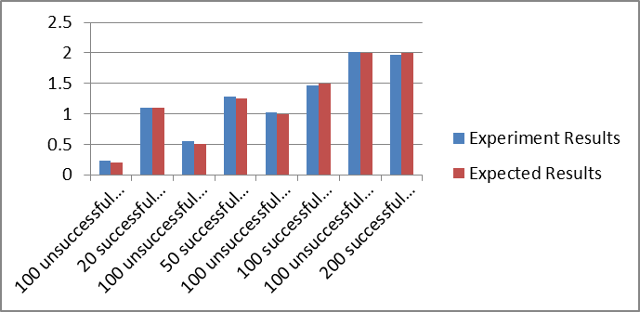

Test B

 | Experiment Results | Expected Results |  | % Difference
100 unsuccessful searches | 0.08 | 0.08 | 0.00%
20 successful searches | 1 | 1.04 | 0.04%
100 unsuccessful searches | 0.25 | 0.2 | 0.20%
50 successful searches | 1.08 | 1.1 | 0.02%
100 unsuccessful searches | 0.46 | 0.41 | 0.11%
100 successful searches | 1.2 | 1.2 | 0.00%
100 unsuccessful searches | 0.87 | 0.82 | 0.06%
200 successful searches | 1.405 | 1.41 | 0.00%

